**Math 120  
2.1 Linear Equations and Rational Equations**

# **Objectives**

1. Solve linear equations in 1 variable.
2. Solve linear equations containing fractions.
3. Recognize identities, conditional equations, and inconsistent equations.
4. Solve rational equations with variables in the denominator.
5. Solve applied problems using linear functions.

# **Topic #1: Solving Linear Equations in One Variable – By “Hand”**



Linear functions can be written in the form



.



Consider the linear functions and . Suppose we want to find where . It may not be obvious that the functions are linear, but the resulting equation is:



The result is the solution set to the equation, we can plug into the original equation to verify:

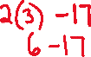

Moreover, the original functions are shown to be equivalent at :



Thinking of linear equations as 2 lines provides the basis for the steps to solving a linear equation:

1. Simplify both sides of the equation as much as possible (get both sides in form). Clear __________________________if necessary (LCM).



1. Collect all variable terms to one side of the equation and the constant terms _______________



1. ____________________the variable to solve.



1. Check the proposed solution in the original equation.



*Example #1* – Solve the Linear Equation

a.

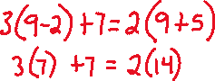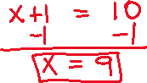

b. Suppose . **Find the zeros of the equation.**  **In other words, find all values such that .**

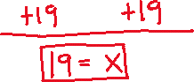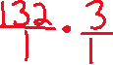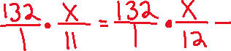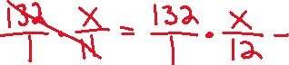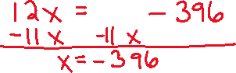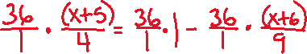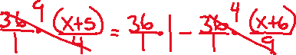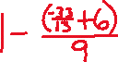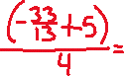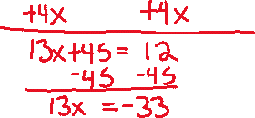

# **Topic #2: Solving Linear Equations in One Variable – With Technology**

We can use a graphing calculator to solve equations.

Recall the equation:

We can input the left side of the equation in the calculator as and the right side of as

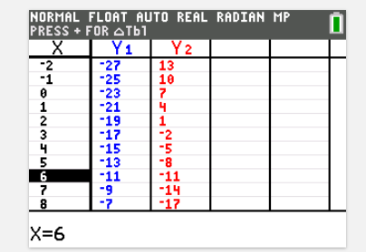Look at a table to see what values makes them equal (in other words .

Based on the table below, we can see that both sides are equivalent when ______________________



We can also look at the graph of the two sides of the equation to see where they meet. This point along the x-axis is the solution.

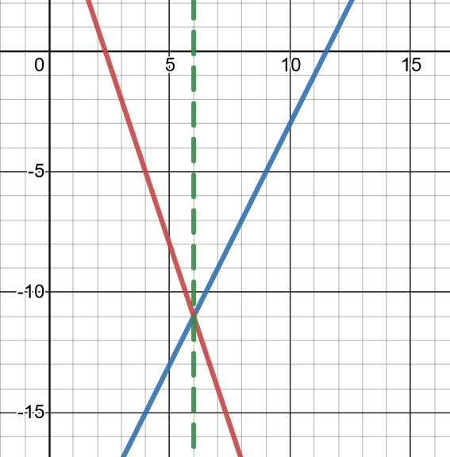



*Example #1* – Use the Table to Write and Solve the Linear Equation

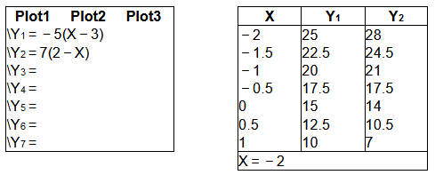



Here .



The resulting equation is

OR .

The solution to the equation is at



*Technology is useful, feel free to use it as you see fit!*

# **Topic #3: Solution Types to Linear Equations**

There are 3 types possible solution sets when solving linear equations:

1) **Conditional** – there is a **_____________** solution set. The equation is only _____________ for certain values.



Recall that the equation:

has a solution when .



This equation is **only** true when , so the equation is **_____________________**



2) **Identity** – there is an **______________** solution set. The equation is always true and x is a real number.



Consider the equation:

Which simplifies to:



Collecting the variable terms and constant terms to either side gives

This equation is **always** true, so the equation is an **____________________**



3) **Inconsistent** – there is **_______________** solution. The equation is **_______________** true, which we can convey with the null symbol:



Consider the equation:

Which simplifies to:



Collecting the variable terms and constant terms to either side gives:



This is **never** true, so the equation is **____________________**



*Example #1* – Solve the Linear Equation and Categorize the Solution Type

a.



b.



c.



***YOU TRY #1* –** Solve the Linear Equation and Categorize the Solution Type

**a. **



**b. **



**c. **

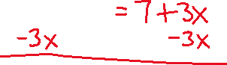

**d. **

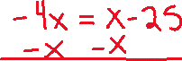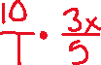

# **Topic #4: Solving Rational Equations**



Rational equations include a variable in the denominator.



Since division by zero is _____________, we cannot accept any solution that makes the denominator ___________.



We clear out denominators with the _______________________________



From there, the equation will become “linear” – we just have to make sure none of the solutions make the denominator zero. Otherwise, we throw it out of the solution set.

Consider the equation:



What is the restricted value?



1. Identify the LCM.

The unique factors are ________________________ (the factor shows up twice, but is only unique once), which gives an LCM of _______________



2. Multiply each term by the LCM ______________ to clear out the denominators:



3. This simplifies to a linear equation:



4. Solve the equation with techniques discussed earlier and check the restricted values:

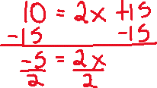

Since this is not the excluded value , the solution works.



A graph also confirms the solution, where:

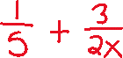

Notice the two sides meet when x = ____________



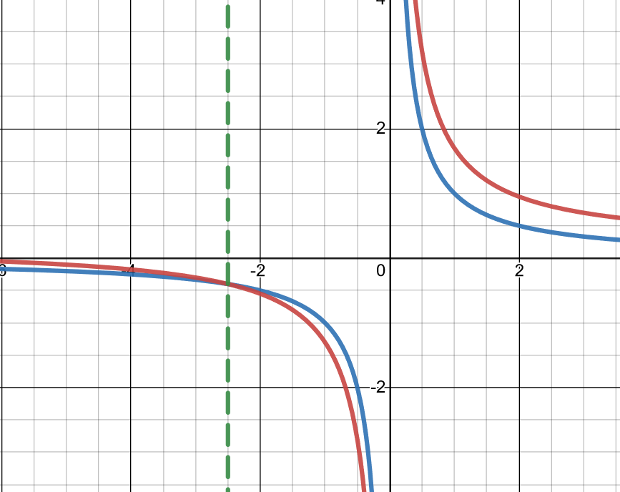

*Example #1* – State the Excluded Values and Solve the Rational Equation



1. Identify restricted values:

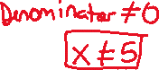

2. Identify LCM



3. Multiply every term by LCM

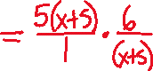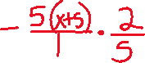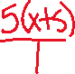

4. Simplify to linear equation.

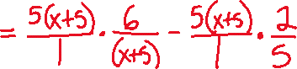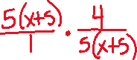

5. Solve and check the restricted values.

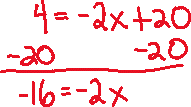

1. Identify restricted values:

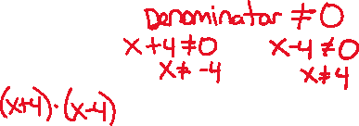

2. Identify LCM

3. Multiply every term by LCM

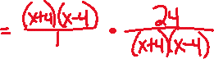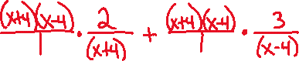

4. Simplify to linear equation.

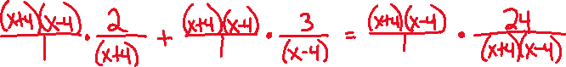

5. Solve and check the restricted values.

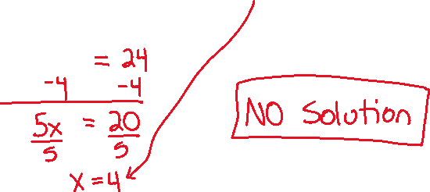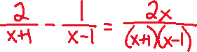

1. Identify restricted values:



2. Identify LCM



3. Multiply every term by LCM

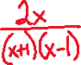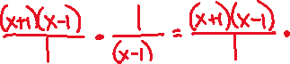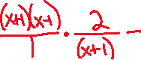

4. Simplify to linear equation.

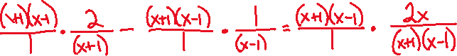

5. Solve and check the restricted values.

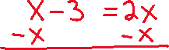

A table generated by a graphing calculator can also solve the equation (notice the parenthesis), where:

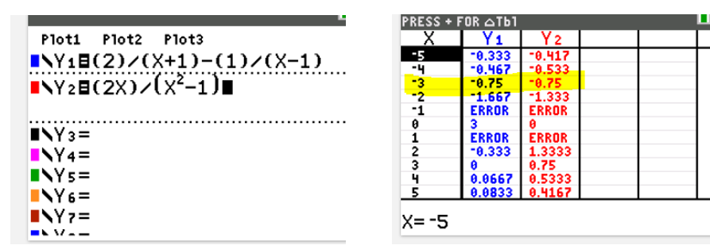



A graph also works!

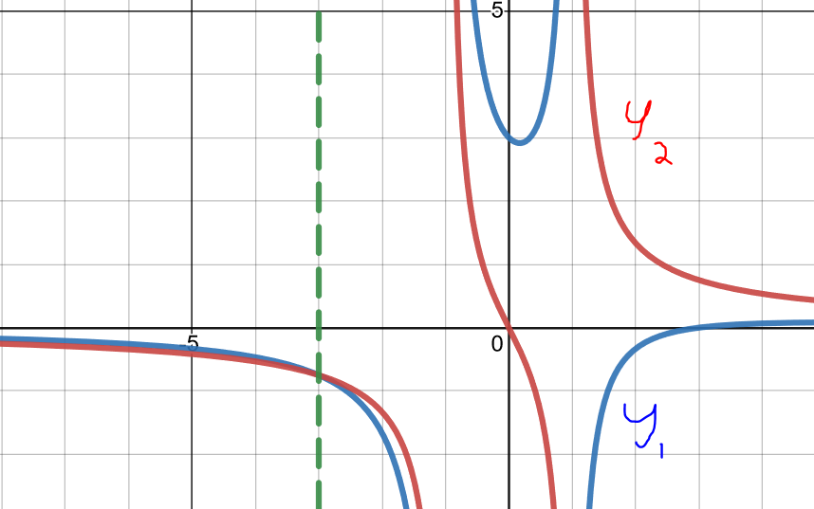

*YOU TRY #2* – Solve the following equations. Make sure to include any restricted values if there are any.

**a. **

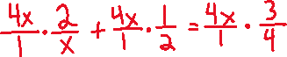

**b. **

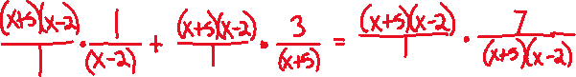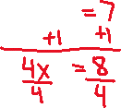

# **Topic #5: Applications of Linear and Rational Equations**

Linear and rational equations are often are used to model data.

*Example #1* – Application of a Linear Equation

The bar graph shows the percentage of US college freshmen with an average grade of A in high school over time.

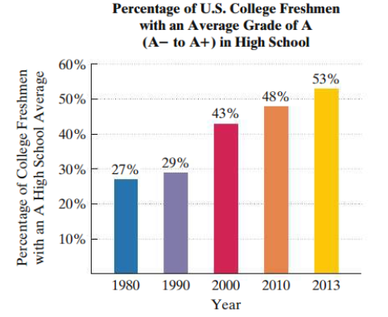

One model for the data is given by the equation:

Where is the percentage with an average grade of A and are years after 1980.

Let x be:



Let *p* be:



a. According to the model, what percentage of US college freshmen have an average grade of A in 2010? How far off is the model from the actual data?



2010 is 30 years after 1980, which gives x = ______



b. Based on the model, when will the percentage of US college freshmen with an average grade of A be 61%?

The projected percentage is given, . Plug into the equation and solve for , which is the number of years after 1980:



*Example #2* – Application of a Rational Equation

A learning curve is a math model that estimates the proportion of correct responses on a test/task in terms of the number of trials/attempts. As the number of trials/attempts increase, the proportion of correct responses increase.

Consider the model

where is the proportion correct and is the number of trials.

Let x be:



Let P(x) be:



a. Find and interpet its meaning.



b. How many trials are necessary to get 95% correct responses?

